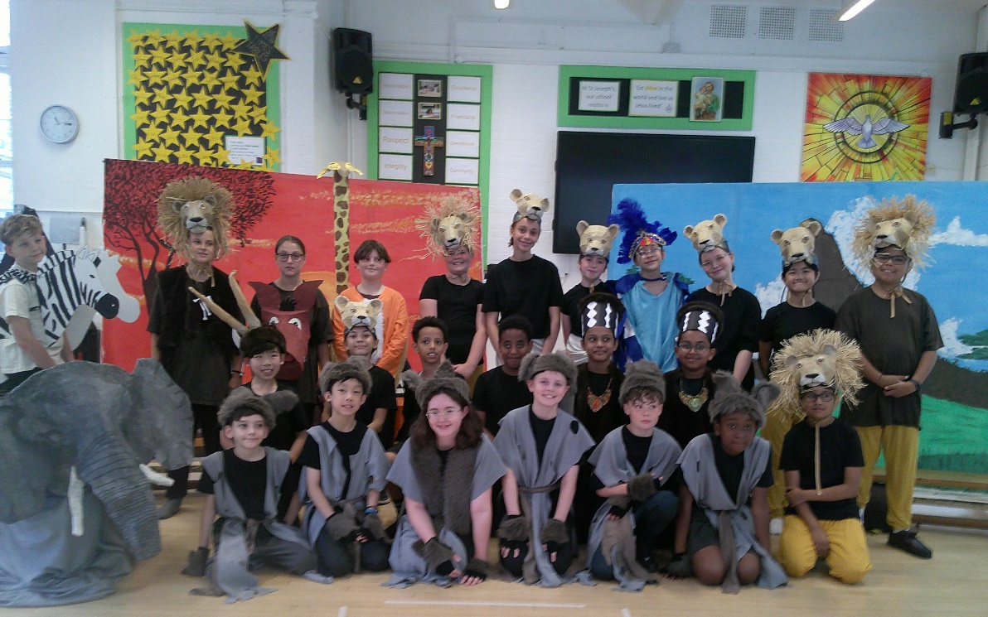
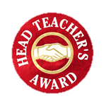

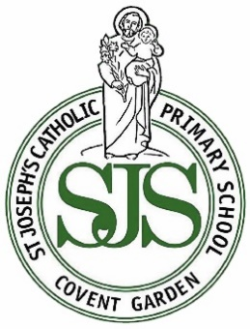
=

I have received and read the St Joseph’s Catholic Primary School newsletter of 17.07.26
Name of child _________________________________________________ Class______________
PLEASE RETURN THIS SLIP TO THE SCHOOL OFFICE AND YOUR CHILD MIGHT WIN A PRIZE :)
The Lion King Performance…
Year 6 put on a fantastic performance of The Lion King this week. They acted with real confidence, sang beautifully and brought so much energy to the stage. The costumes were a highlight — creative, bold and clearly made with a lot of care. It was wonderful to see the children working together and producing something they can genuinely be proud of.

Farewell to Mrs Lewis…This week we say goodbye to Mrs Lewis who is leaving to move out of London and be closer to her family. It has been a privilege working with Mrs Lewis and she has been a valued member of our staff, bringing dedication and care to her work with pupils. We thank her sincerely for everything she has contributed to our school community and wish her every happiness in this next chapter.
We are also pleased to announce that Mrs De Kretser will be joining us as the new Year 3 teacher from September. She brings experience and a passion for teaching and we look forward to welcoming her to St Joseph’s.

Welcome to Ms De Kretser

Dear Parents and Carers,
A heartfelt thank you to our staff for their dedication and commitment throughout the year, and to all parents and carers for your continued support. Your partnership makes a huge difference.

It’s onwards and upwards for Year 6 as we wish them well for the move to secondary school — they leave us ready for the next step and we are incredibly proud of them.

Do scan the QR code on page 3 of this newsletter to see what free or low-cost activities and events are available throughout the summer holidays for families in Camden. They include everything from K-pop dance and film-making to creative workshops, storytelling, family events, community walks, film screenings and a live orchestral concert for under-fives. Check out the library activities too!
With best wishes, Ms O’Donovan (Head of School) and Ms Richardson (Executive Headteacher)

Go, shine in the world & live as Jesus lived
St Joseph’s Catholic Primary School
Newsletter

Friday 17th July 2026
www.stjosephs.camden.sch.uk
admin@stjosephs.camden.sch.uk


Important Dates
for your Diary…

Thursday 3rd September
Back to school- Doors open at 8.40am

Dragon Hall After School Club – Enrolment Now Open for 2026/27!
Dragon Hall's free After School Club is now accepting registrations for the 2026/27 school year!
Running every Monday, Tuesday and Friday, our club offers young people aged 8–11 the chance to take part in a variety of creative, sports and technology-based activities, helping them build confidence and develop new skills in a safe and supportive environment.
Our regular extracurricular clubs include Code Club, Drama and Music Production, with new activities introduced throughout the year based on young people's interests.
Located 1 minute from St Joseph's, our team will collect children directly from the school and chaperone them to Dragon Hall.
- Ages 8–11
- Completely FREE
- School collection included
To find out more or to be sent our waiting list form, please contact elliot@dragonhall.org.uk
Attendance…In September we will continue to place a strict focus on attendance and punctuality as both have a direct impact on children’s learning and long-term life chances. Every morning begins with essential reading lessons, and any lateness means children miss the most important learning of the day.
In the Autumn term, parents of pupils with concerning attendance will be required to meet with the Head of School and Camden’s Inclusion Officer to review individual attendance and agree clear actions.
• Good Attendance: 95% or more (9 days missed)
• Concerning: 90% -94% ( 19 days or more missed)
Strong attendance is a non-negotiable expectation. Thank you for ensuring your child is in school every day and on time, ready for learning.

Summer Savings…
Between 25 June and 1 September 2026 there is a temporary reduction on VAT from 20% to 5% on children`s meals in restaurants, children and family tickets to cinemas, theatres, concerts, exhibitions and a wide range of other attractions. In addition, there is to be free bus travel during August for children aged 5 to 15 in England.
Details of Summer Savings participating venues can be found on the attraction finder website, which can be accessed via the following link:
https://summersavings.gov.uk




Don’t let a little worry turn into a big one...
If you or your child are worried about something or have any questions, please phone the
school office and book an appointment to see their class teacher, Mrs Stewart or Ms O’Donovan.
We are always really pleased to meet with you and chat things through.

Our Prayer…
Loving God, Thank You for guiding our school community through this year. Watch over our families and staff and help us return in September refreshed and ready for the year ahead. Amen

Amen.

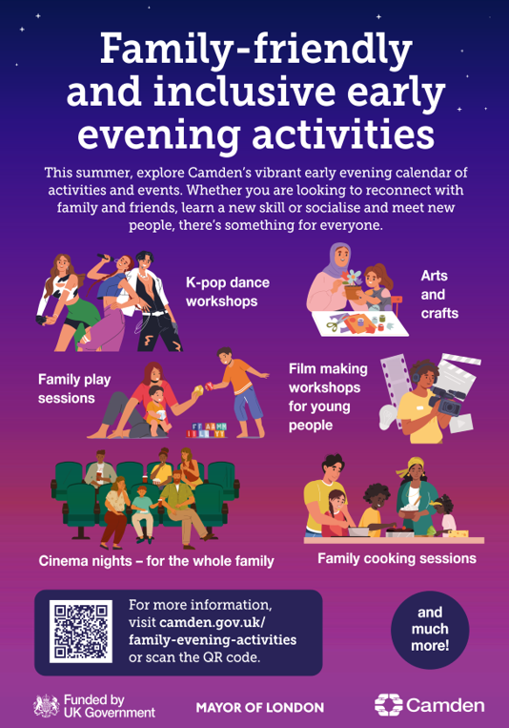

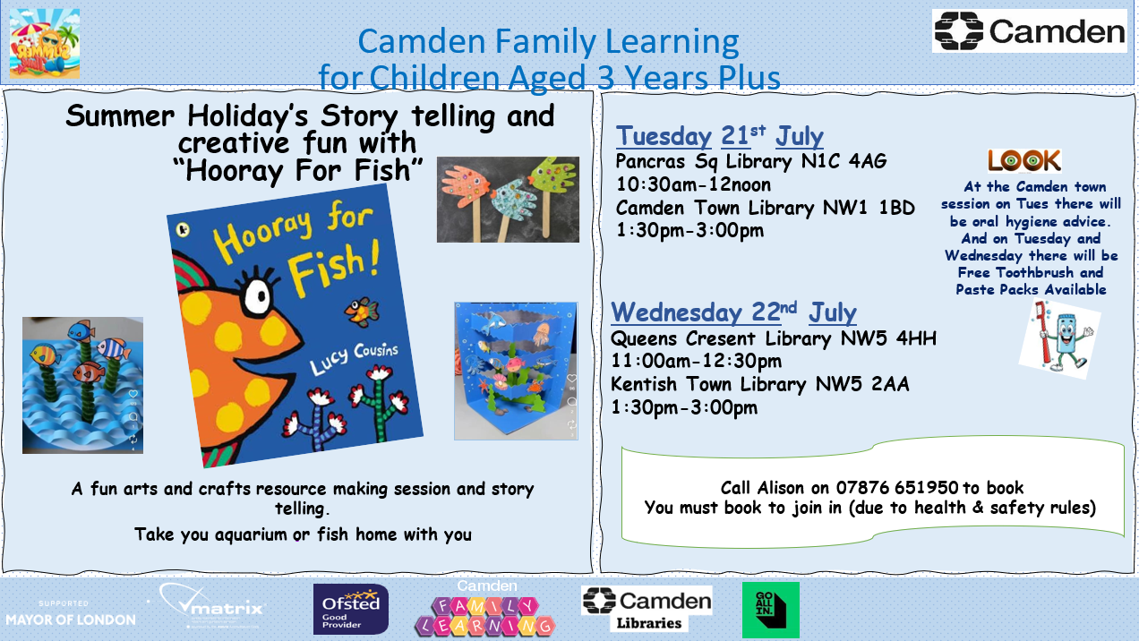
Reading Over the Holidays…
As we approach the summer holidays, we want to encourage every child to keep reading regularly. Just 10–15 minutes a day makes a huge difference to vocabulary, confidence and fluency, and helps children return to school in September ready to learn.
Families living near Macklin Street are lucky to have several excellent local libraries within a short walk. They are free to join, offer a wide range of children’s books and run summer reading activities
We encourage all families to visit a library over the holidays and help children choose books they are excited about. Reading anything they enjoy — stories, comics, non-fiction, poetry — builds confidence and keeps skills sharp.
Thank you for supporting your child’s reading. It truly shapes their future learning and life chances.



