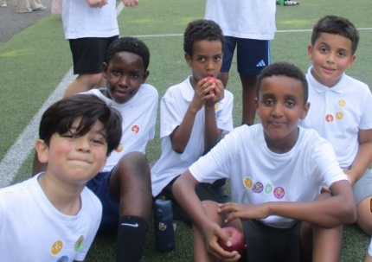

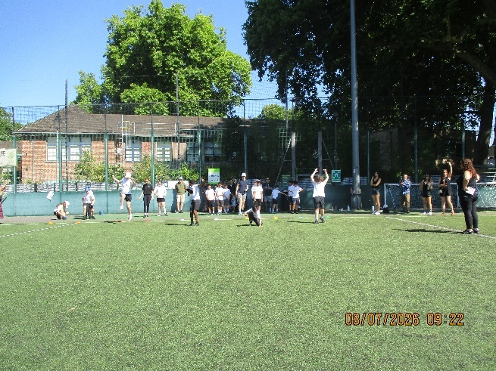
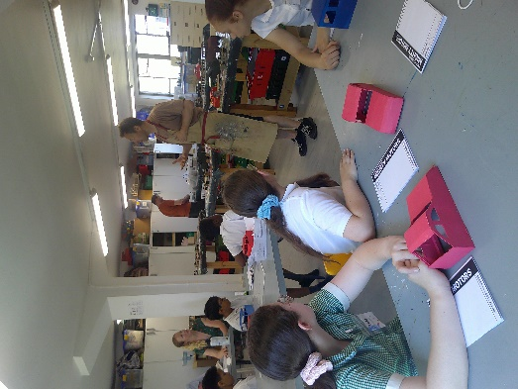

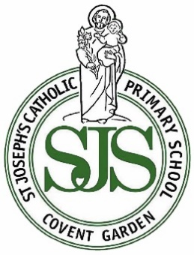
Super Sports Day…

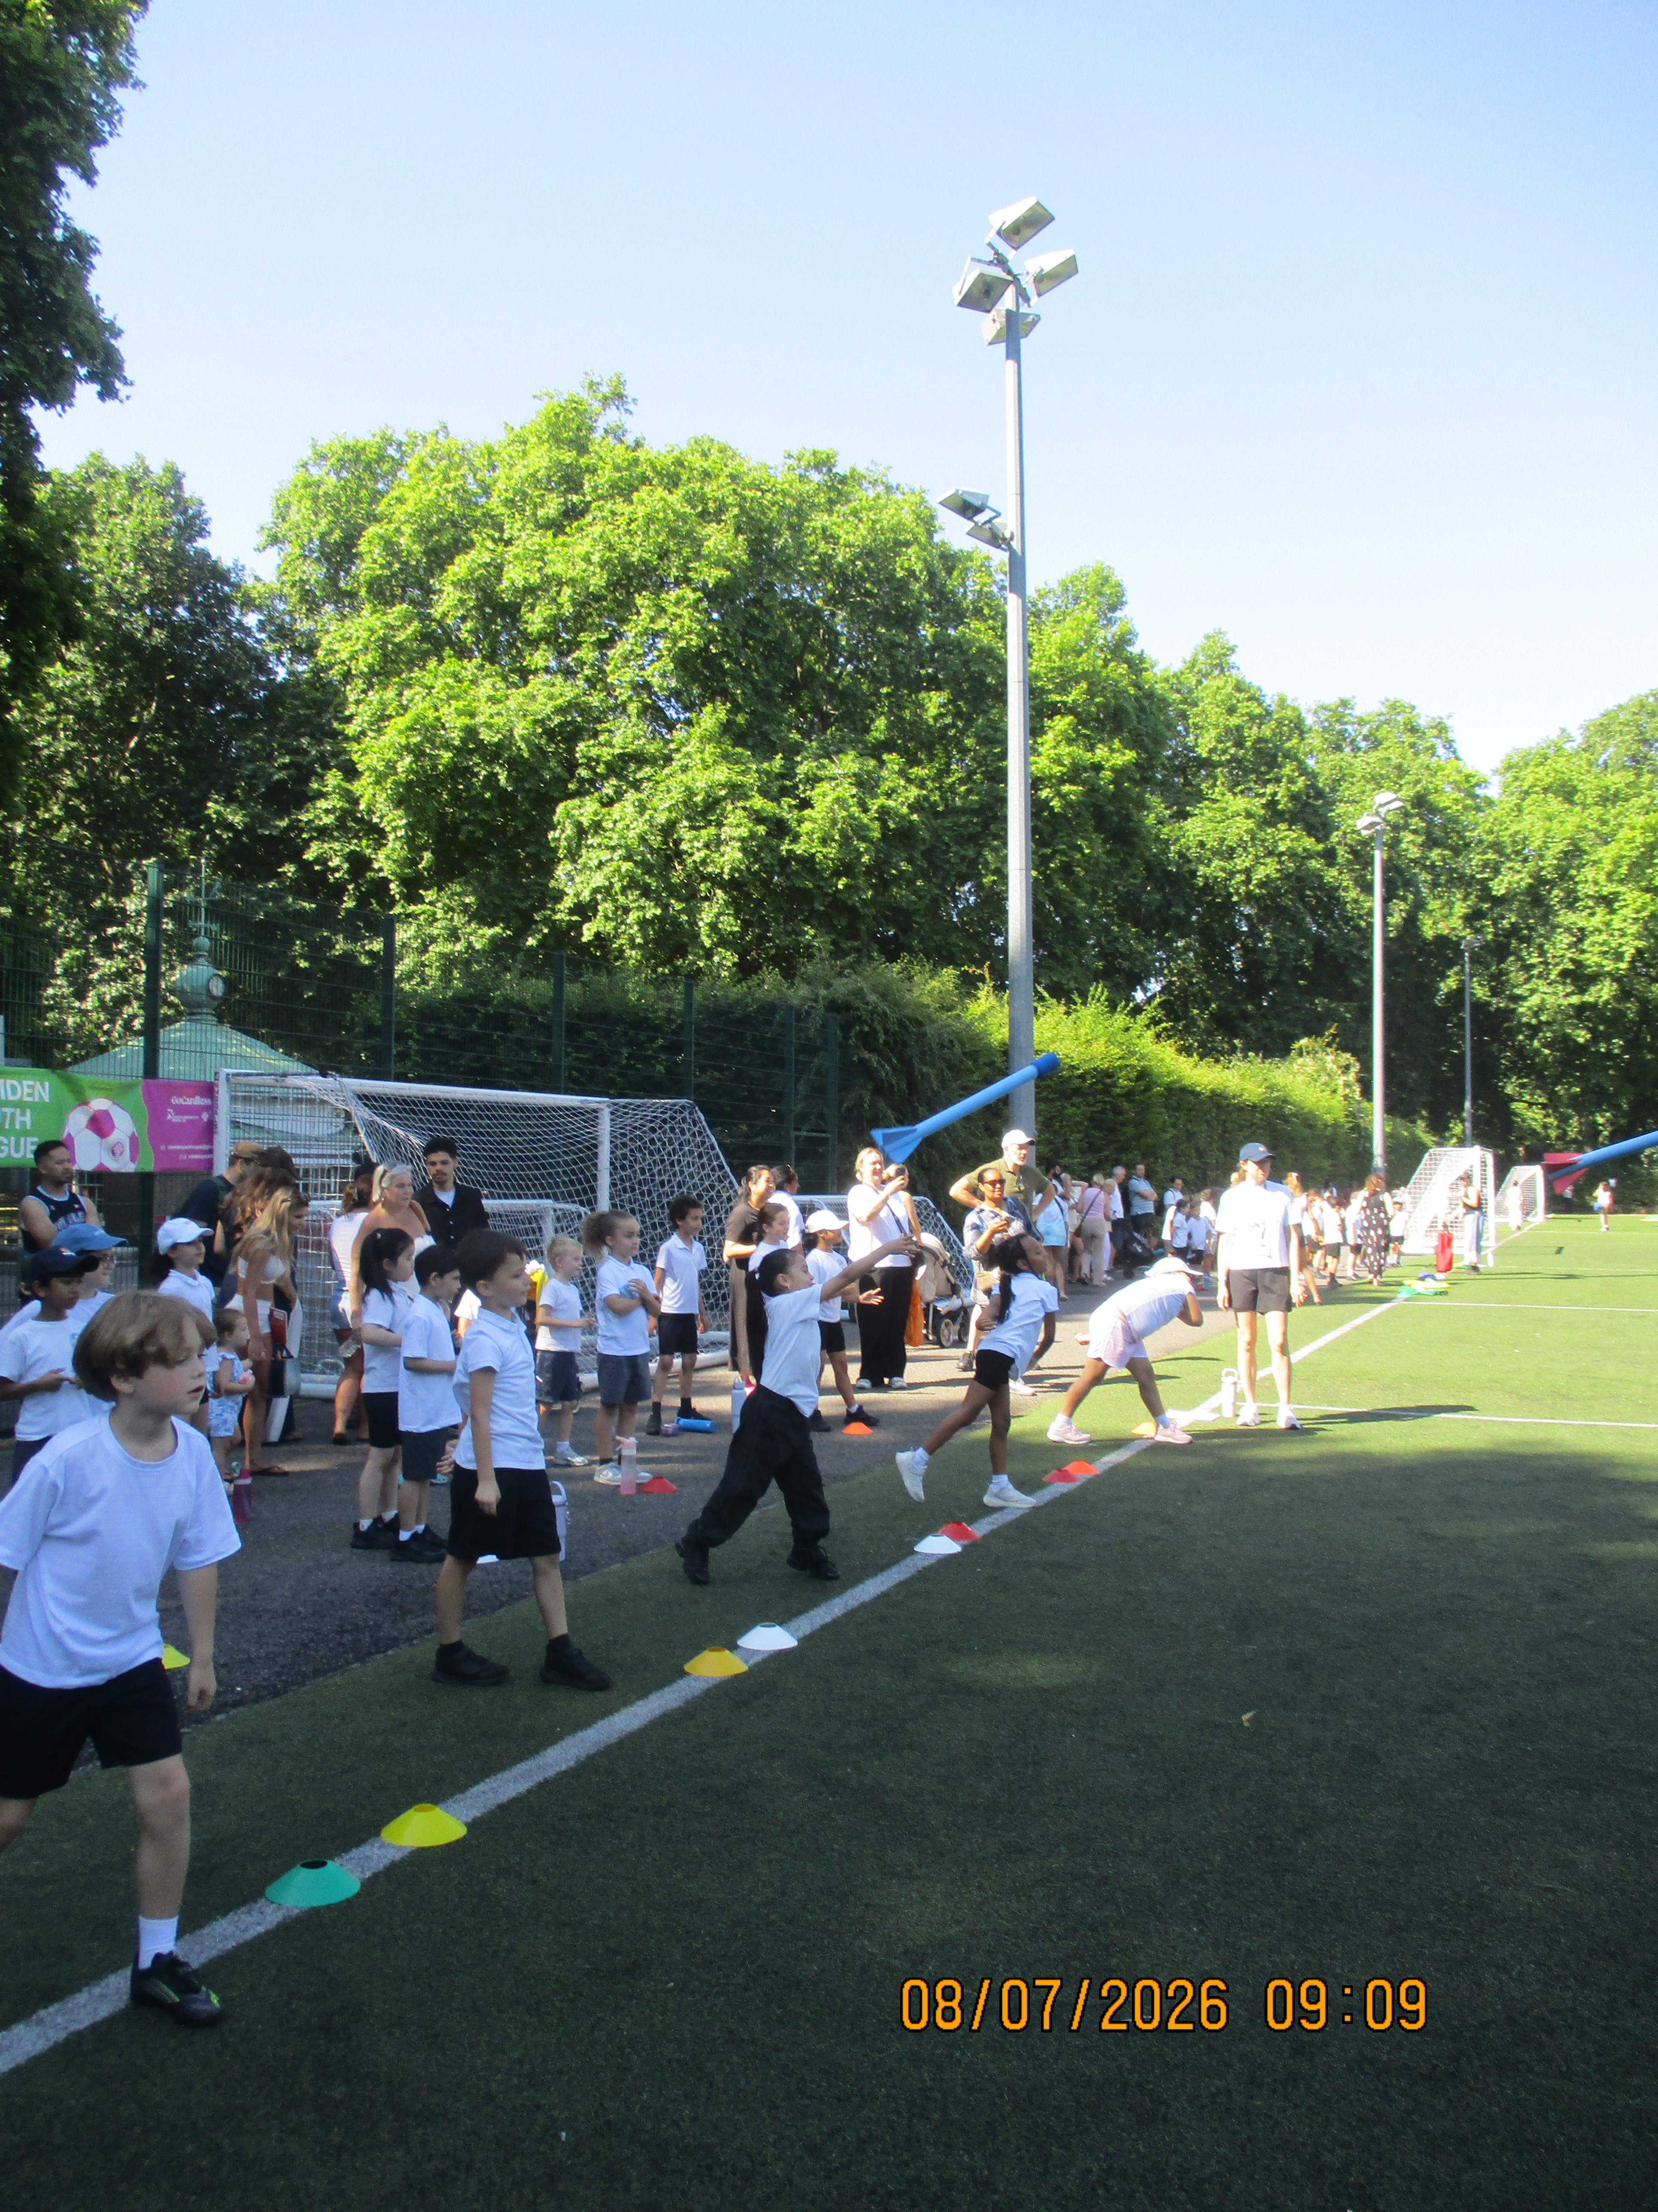

Dear Parents and Carers,

Sports Day was a huge success on Wednesday. The children took part in a range of activities including long jump, sprint races, the sack race, the egg-and-spoon race and turbo javelins. Their enthusiasm and teamwork were fantastic.
Our Year 6 pupils have also completed their product design project this week and are absolutely delighted with their very impressive motorised vehicles. We will be showcasing these in next week’s assembly so the whole school can celebrate their achievements.
Next week is the final week of term for pupils. They will be receiving their holiday homework, which is project-based and linked to their learning for the Autumn term. We hope they enjoy getting started on it over the summer.
With best wishes, Ms O’Donovan (Head of School) and Ms Richardson (Executive Headteacher)

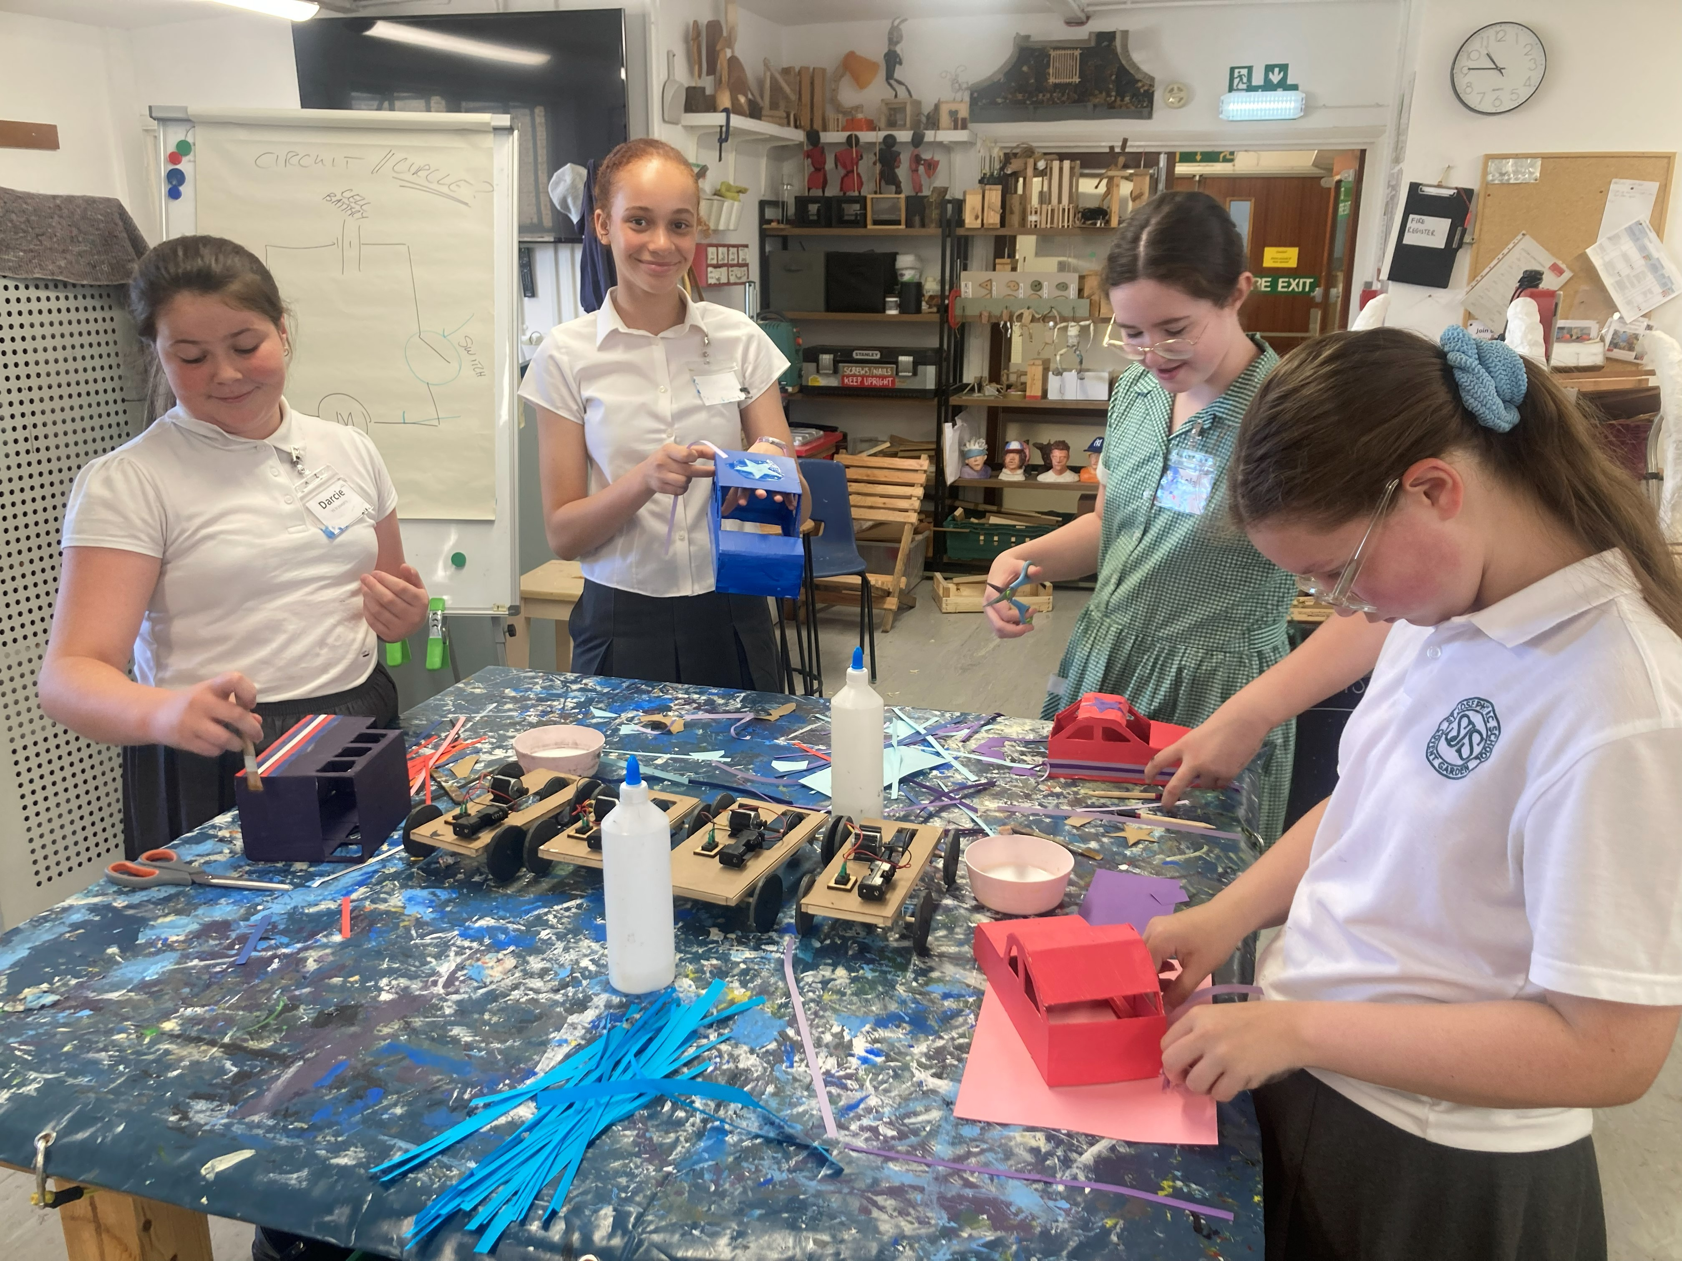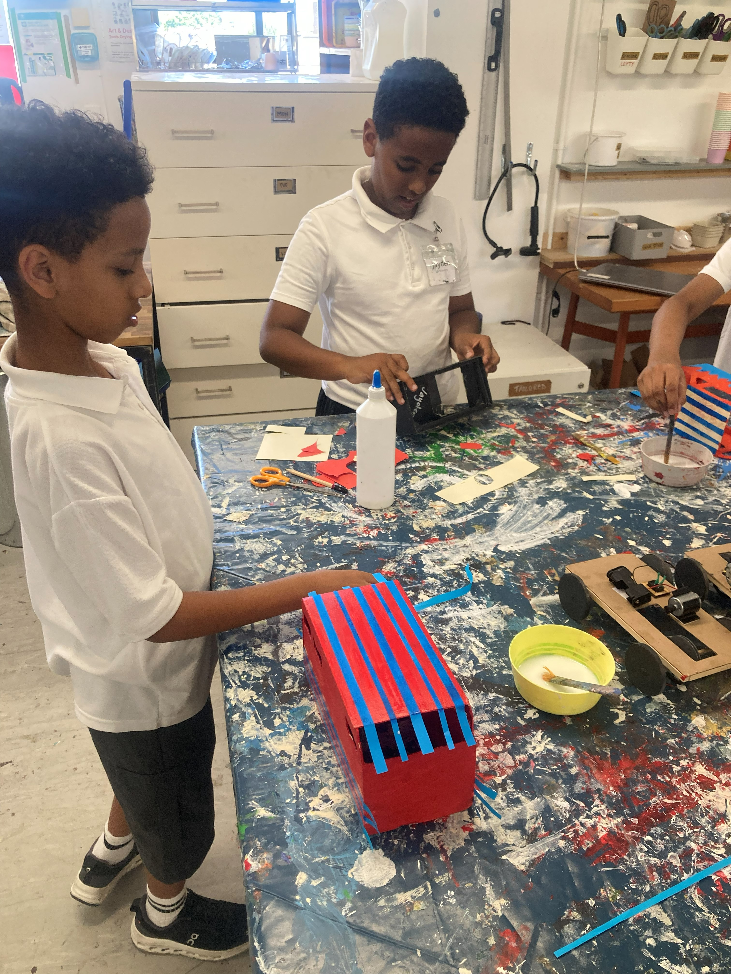

I have received and read the St Joseph’s Catholic Primary School newsletter of 9.07.26
Name of child _________________________________________________ Class______________
PLEASE RETURN THIS SLIP TO THE SCHOOL OFFICE AND YOUR CHILD MIGHT WIN A PRIZE :)
Go, shine in the world & live as Jesus lived
St Joseph’s Catholic Primary School
Newsletter

Thursday 9th July 2026
www.stjosephs.camden.sch.uk
admin@stjosephs.camden.sch.uk

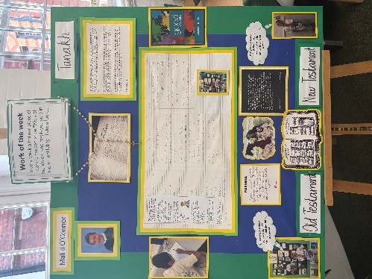

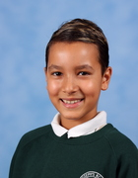

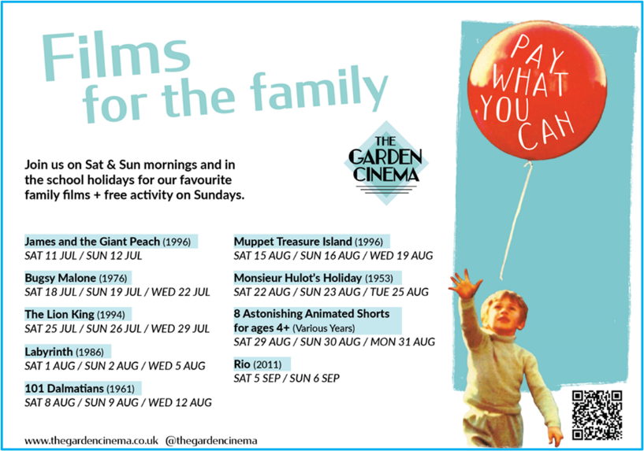
Attendance…
Congratulations to Year 2 and Nursery who received our attendance trophy for having the best attendance for this week. This means that both classes will enjoy some extra playtime next week. Well done Year 2 and Nursery!
Please make sure your child is in school every single day unless they are very unwell.

Work of the Week…

Each week, we proudly showcase an outstanding piece of children’s work in our school lobby. This week, Maliki in Year 5 has been chosen for his excellent RE work. He has demonstrated an impressive understanding of biblical texts, including psalms, parables and letters. Maliki has thoughtfully interpreted their messages and reflected on their relevance for modern life. Well done Maliki!

The winner of the Friday newsletter slip prize this week is John in Year 3
He has won a £10 gift
voucher to spend at Waterstones.

Happy reading Betsy!


Important Dates
for your Diary…
Tomorrow is Academic Review Day
Tuesday 14th July at 9.05am
Year 3 Presentation to Parents

Tuesday 14th July at 2.00pm
Year 6 Production

Thursday 16th July at 9.05am
Year 1 and Year 2 Presentation to Parents

Thursday 16th July at 2.30pm
Year 6 Leavers’ Service

Friday 17th July
Last day of the Summer term

Thursday 3rd September
Back to school- Doors open at 8.40am

Our Prayer for Kindness…
Loving Jesus, You teach us to love one another and to follow Your example in all we do.
Strengthen us to make good choices, to show kindness and to be a light for others in our school.
St Joseph, pray for our school and help us to work with patience and joy. Amen.




Don’t let a little worry turn into a big one...
If you or your child are worried about something or have any questions, please phone the
school office and book an appointment to see their class teacher, Mrs Stewart or Ms O’Donovan.
We are always really pleased to meet with you and chat things through.


