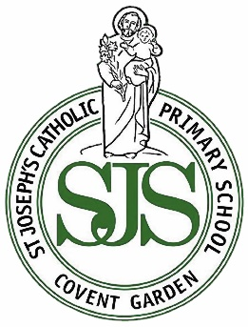
Go, shine in the world & live as Jesus lived
St Joseph’s Catholic Primary School
Newsletter

Friday 3rd July 2026
www.stjosephs.camden.sch.uk
admin@stjosephs.camden.sch.uk



Dear Parents and Carers,
Thank you to parents and carers who joined us yesterday to celebrate Year Four and Year Five’s many achievements this academic year. It was such a joy to watch and there was so much to be proud of!

Classes enjoyed their Summer Parties this afternoon- There was dancing, burgers, games and a special raffle with some excellent prizes.

As you know, last week we rearranged a couple of the Presentations to Parents:
- Year One and Year Two Presentation is on Thursday 9th July at 2.45pm in the school hall
- Year Three’s Presentation is on Tuesday 14th July at 9.05am in the school hall
We look forward to welcoming you to these events and celebrating the children’s hard work together.
With best wishes, Ms O’Donovan (Head of School) and Ms Richardson (Executive Headteacher)

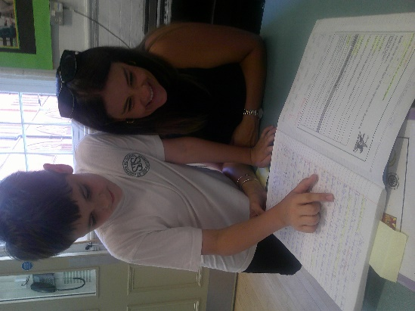
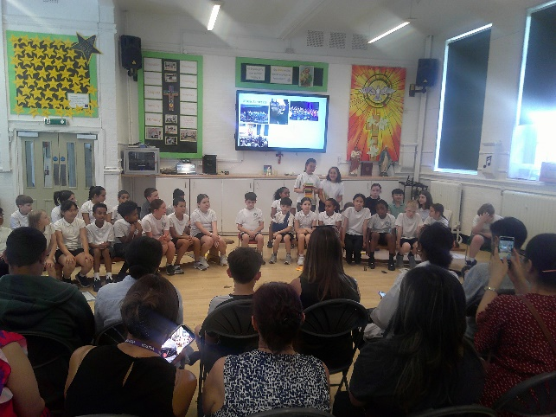
A Wonderful Celebration of Learning…
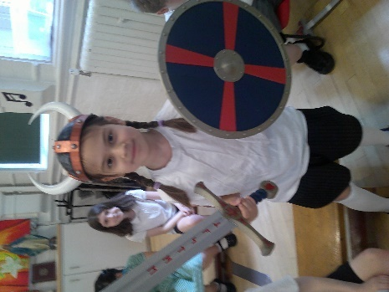


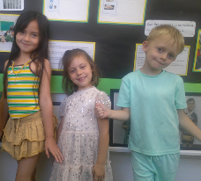
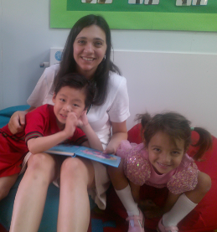
Summer Class Parties…
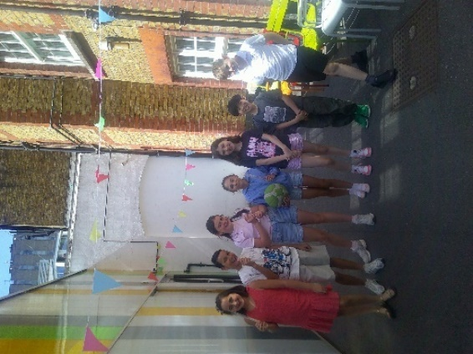

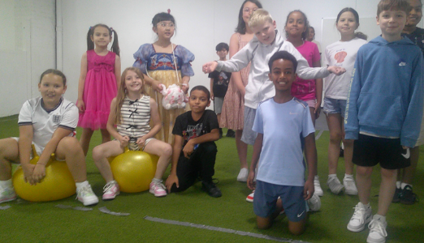

I have received and read the St Joseph’s Catholic Primary School newsletter of 03.07.26
Name of child _________________________________________________ Class______________
PLEASE RETURN THIS SLIP TO THE SCHOOL OFFICE AND YOUR CHILD MIGHT WIN A PRIZE :)


Sports Day
Wednesday 8th July

Venue: Coram’s Fields

Year 1, Year 2 and Year 3 will be leaving school at 9.05am for a 9.30am start.
Year 4, Year 5 and Year 6 will be leaving school at 1.05pm for a 1.30pm start. Children will be walked back to school for 3.30 but parents can collect from Coram’s Field if they prefer.

Checklist:

- Wear your PE kit
- Wear a sun hat/cap
- Have sunscreen on
- Bring water (this will also be supplied)

Person of the Week…
Each week, one student from every class is selected as our Person of the Week.
These students are recognised for consistently demonstrating our school values.

Nursery: Millie
Reception: Skylar
Year 1: Lewis
Year 2: Hector
Year 3: Joseph
Year 4: Henry
Year 5: Sebastian
Year 6: Darcie
Attendance…
Congratulations to Nursery who received our attendance trophy for having the best attendance for this week. This means that the class will enjoy some extra playtime next week.
Well done Nursery!

Please make sure your child is in school every single day unless they are very unwell.

What are our
school values?
Excellence
Determination
Inspiration
Compassion
Integrity
Friendship
Community
Honesty, Dignity, & Respect:



Important Dates
for your Diary…
Wednesday 8th July
Sports Day

Thursday 9th July at 2.45pm
Year 1 and Year 2 Presentation to Parents

Friday 10th July
Academic Review Day

Tuesday 14th July at 9.05am
Year 3 Presentation to Parents
Tuesday 14th July at 2.00pm
Year 6 Production

Thursday 16th July at 2.30pm
Year 6 Leavers’ Service

Friday 17th July
Last day of the Summer term

1st and 2nd September
INSET days-school closed to pupils
Thursday 3rd September- Back to school



The winner of the Friday newsletter slip prize this week is Ivan in Year 1
He has won a £10 gift
voucher to spend at Waterstones.

Happy reading Betsy!



Our Prayer for Compassion
Loving God,
Fill our hearts with compassion so we may treat others with kindness and understanding.
Help us to notice when someone needs a friend, a smile or a helping hand.
May our school community be a place where every person feels valued, supported and cared for. Amen

Amen.



Don’t let a little worry turn into a big one...
If you or your child are worried about something or have any questions, please phone the
school office and book an appointment to see their class teacher, Mrs Stewart or Ms O’Donovan.
We are always really pleased to meet with you and chat things through.

The Garden Cinema

The Garden Cinema hosts family film screenings every Saturday & Sunday morning, and on weekdays during the school holidays. The screenings are 'Pay What You Can', which means you’re free to pay as much or as little as you can afford.

On Sundays the films are followed by free fun and creative activities for children. Upcoming films include 'James and the Giant Peach', 'The Lion King', 'Bugsy Malone' and 'Muppet Treasure Island'.







