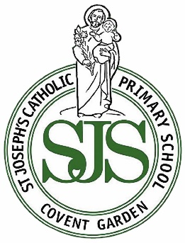
Go, shine in the world & live as Jesus lived
St Joseph’s Catholic Primary School
Newsletter

Friday 26th June 2026
www.stjosephs.camden.sch.uk
admin@stjosephs.camden.sch.uk



Dear Parents and Carers,

Our Year 6 pupils had a fantastic time at PGL this week enjoying a range of outdoor activities including raft building, climbing, archery and zip lining. It’s such a joy to look through the photos shared below. All of the photos will be given to families at the Leavers’ Service on 16th July. A huge THANK YOU to our staff Mrs Hall, Ms Dee and Ms Florio for making it happen. What a team!

Do check the dates overleaf and make a note of them. Year 6 have more to look forward to as their secondary transfer day is on Thursday 2nd July.

With best wishes, Ms O’Donovan (Head of School) and Ms Richardson (Executive Headteacher)



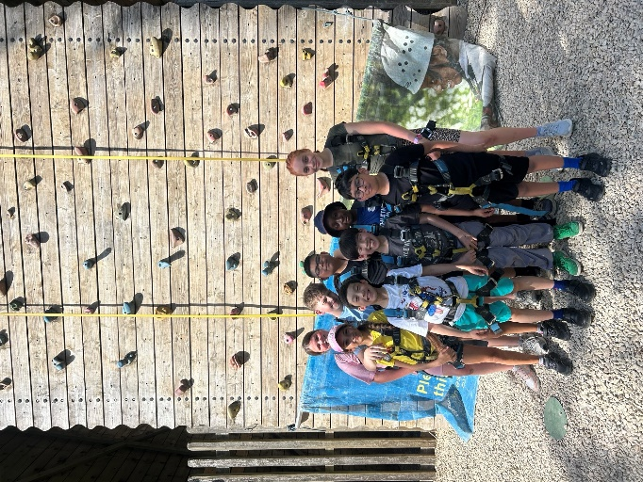





I have received and read the St Joseph’s Catholic Primary School newsletter of 25.6.26
Name of child _________________________________________________ Class______________
PLEASE RETURN THIS SLIP TO THE SCHOOL OFFICE AND YOUR CHILD MIGHT WIN A PRIZE :)

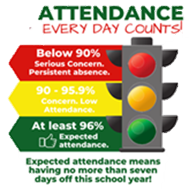
Work of the Week…
Each week, we proudly showcase an outstanding piece of children’s work in our school lobby. Arwen has been enjoying the story Mr Gumpy’s Outing and has carefully created her own boat, adding some of the characters from the story. She has also used her growing phonic knowledge to write some of the characters’ names — a fantastic early-writing achievement Arwen!
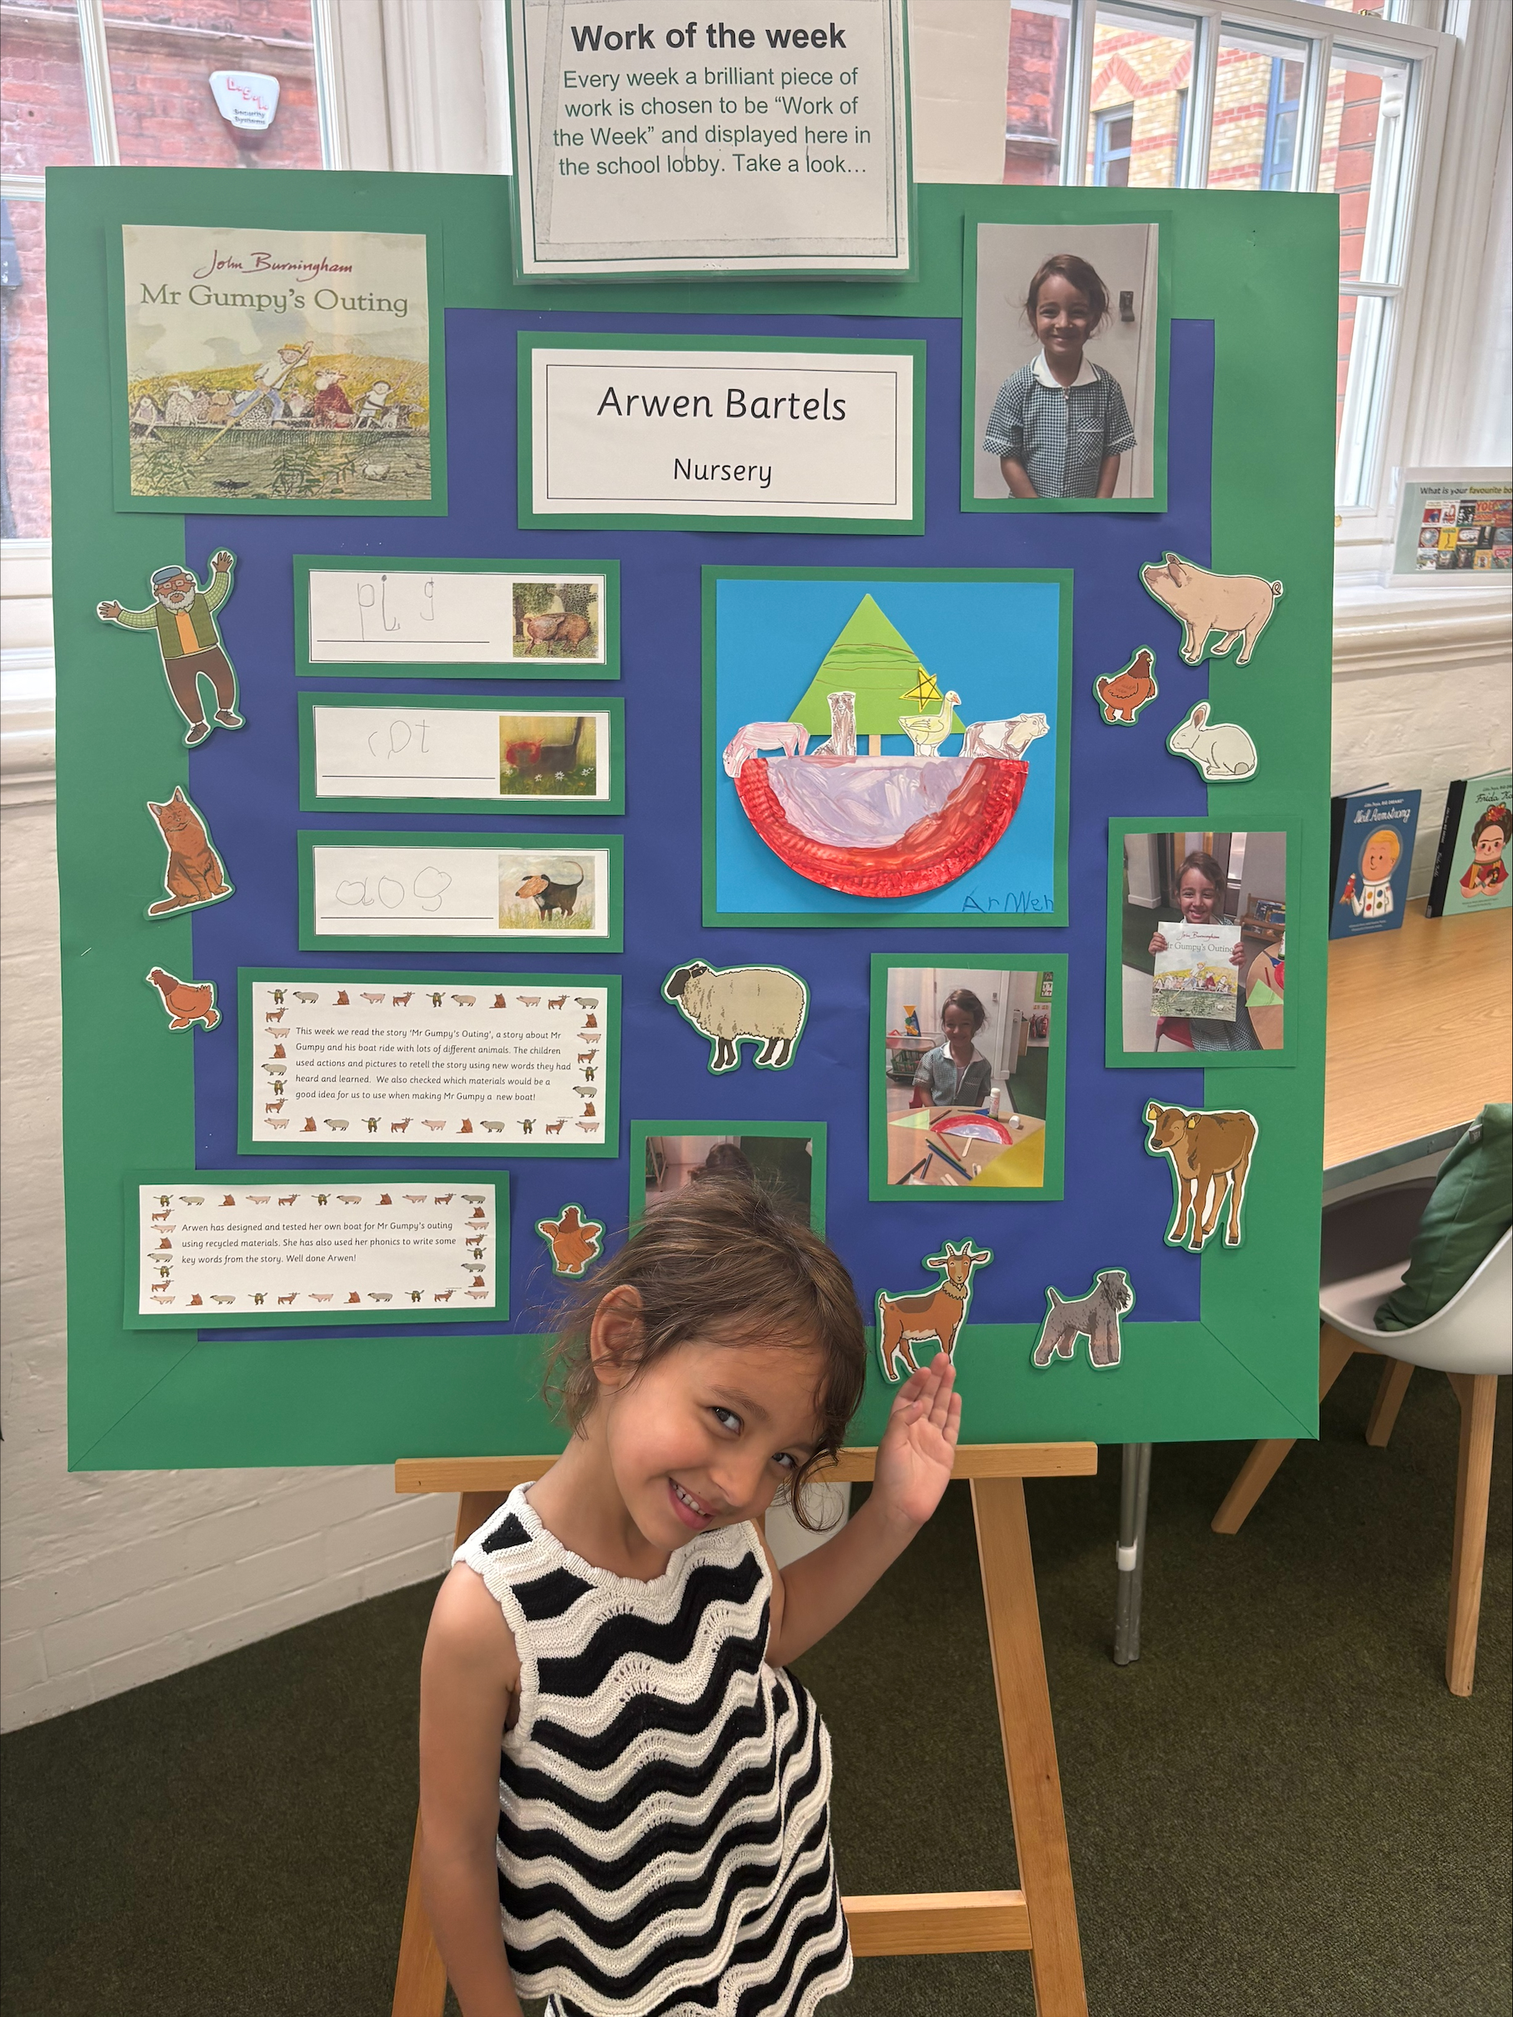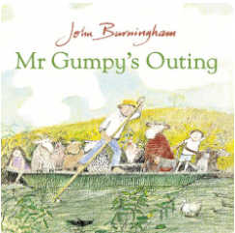
Well done, Arwen
— wonderful work!

Attendance…
Congratulations to Nursery who received our attendance trophy for having the best attendance for this week. This means that the class will enjoy some extra playtime next week.
Well done Nursery!

Please make sure your child is in school every single day unless they are very unwell.

Person of the Week…
Each week, one student from every class is selected as our Person of the Week.
These students are recognised for consistently demonstrating our school values.

Nursery: Nancy
Reception: Kingsley
Year 1: Loulia
Year 2: Lionel
Year 3: Alexander
Year 4: Olivia
Year 5: Natnael
Year 6: All of our Y6 pupils


What are our
school values?
Excellence
Determination
Inspiration
Compassion
Integrity
Friendship
Community
Honesty, Dignity, & Respect:

Important Dates
for your Diary…

Thursday 2nd July at 2.45pm
Year 4 and Year 5 Presentation to Parents

Wednesday 8th July
Sports Day

Friday 10th July
Academic Review Day

Tuesday 14th July at 2.00pm
Year 6 Production

Thursday 16th July at 2.30pm
Year 6 Leavers’ Service

Friday 17th July
Last day of the Summer term

1st and 2nd September
INSET days-school closed to pupils

Thursday 3rd September
Pupils return to school

The winner of the Friday newsletter slip prize this week is Aiden in Year 3
He has won a £10 gift
voucher to spend at Waterstones.

Happy reading Betsy!




Our Prayer for Our School Community...
Loving God,
Thank You for being with us in our school each day. Help us to be kind, to listen well and to make good choices.
Bless our friends, our families and everyone who helps us to learn and to grow.
Fill our hearts with Your peace. Amen.

Amen.



Don’t let a little worry turn into a big one...
If you or your child are worried about something or have any questions, please phone the
school office and book an appointment to see their class teacher, Mrs Stewart or Ms O’Donovan.
We are always really pleased to meet with you and chat things through.






